Sauce Demo (Swag Labs) - web application
Automation & Regression test cases
Module Name: Sauce Demo - login and shopping flow (Automation & Regression Analysis)
Test case ID: TC0010
Platform: Web application (https://www.saucedemo.com), Google Chrome on Windows
Login Method: username + password
Tester Name: VIDHI PATEL

Scenario ID: 1
Scenario: Regression: login with valid credentials
Test steps:
- Enter valid username : standard_user
- Enter valid password : secret_sauce
- Click on login
Expected: User is logged in and the Products page opens
Actual: Products page opened
Status: Pass

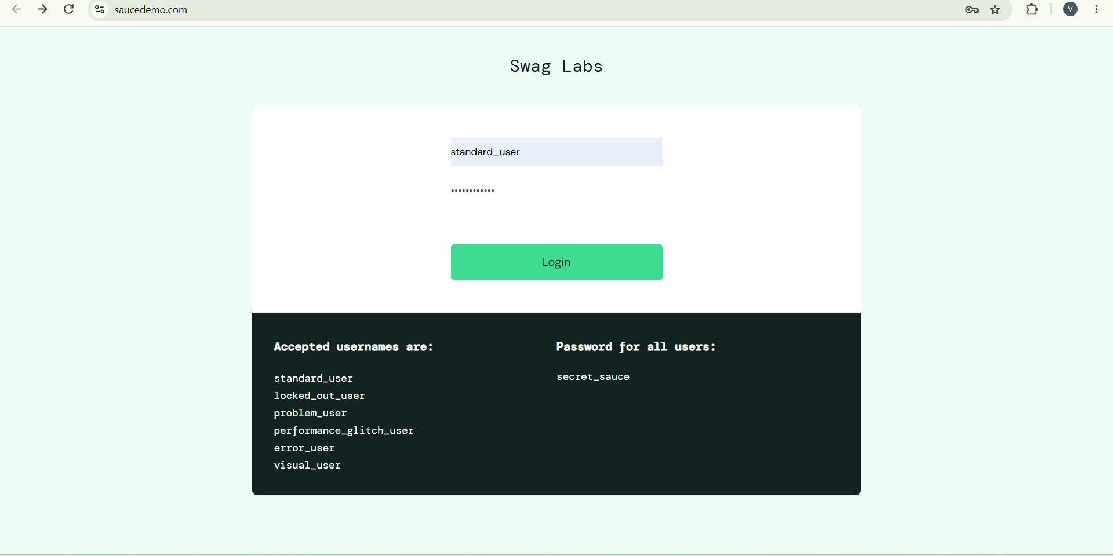
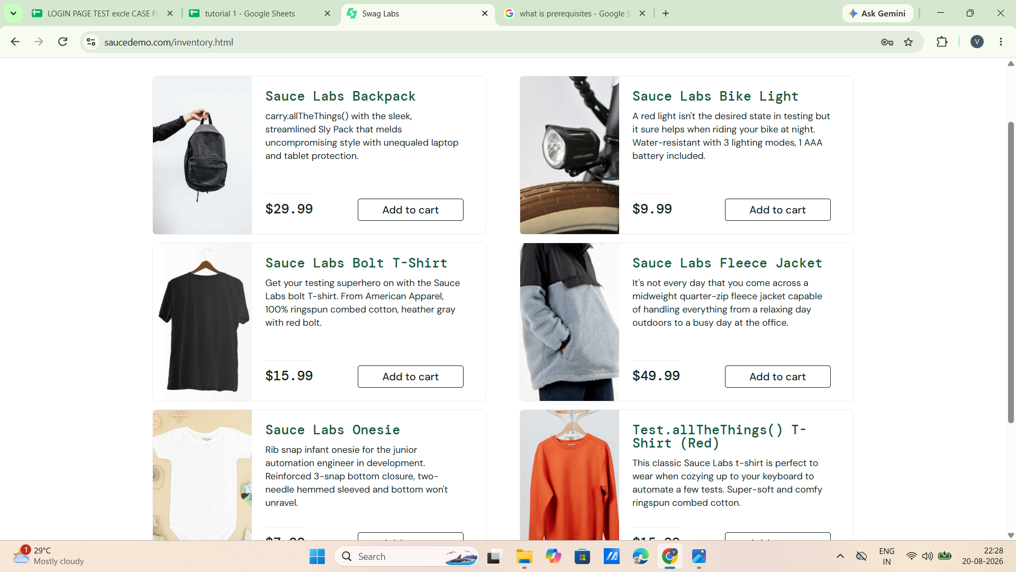

Scenario ID: 2
Scenario: Regression: login with valid username and invalid password
Test steps:
- Enter valid username : standard_user
- Enter invalid password : Godisgreat
- Click on login
Expected: Epic sadface: Username and password do not match any user in this service
Actual: Error displayed: Epic sadface: Username and password do not match any user in this service
Status: Pass

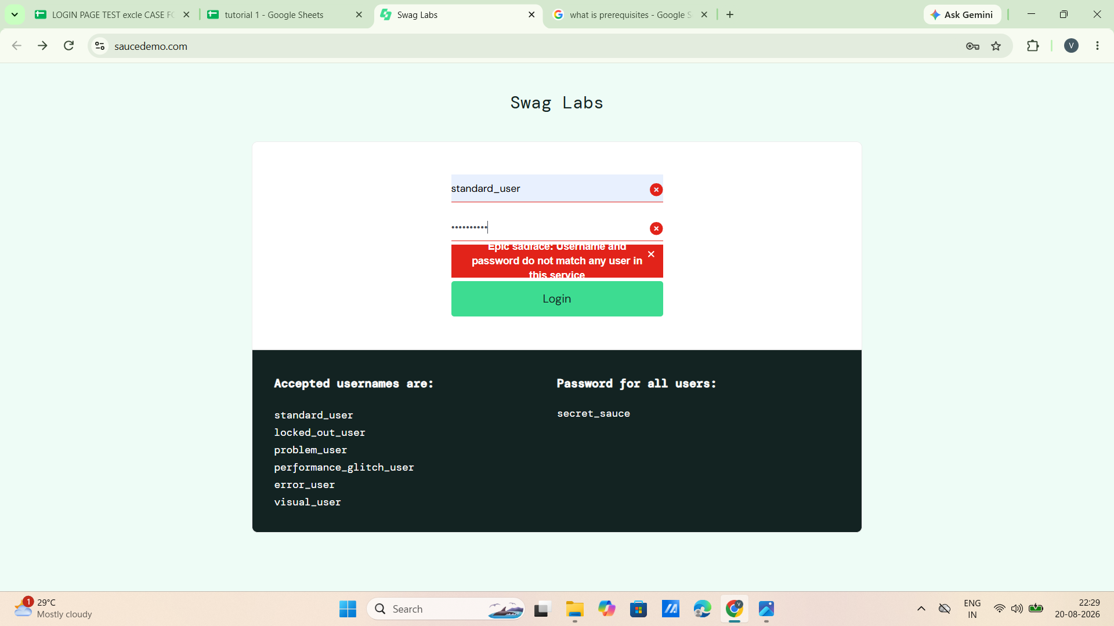

Scenario ID: 3
Scenario: Regression: login with invalid username and valid password
Test steps:
- Enter invalid username : vidhi patel
- Enter valid password : secret_sauce
- Click on login
Expected: Epic sadface: Username and password do not match any user in this service
Actual: Error displayed: Epic sadface: Username and password do not match any user in this service
Status: Pass

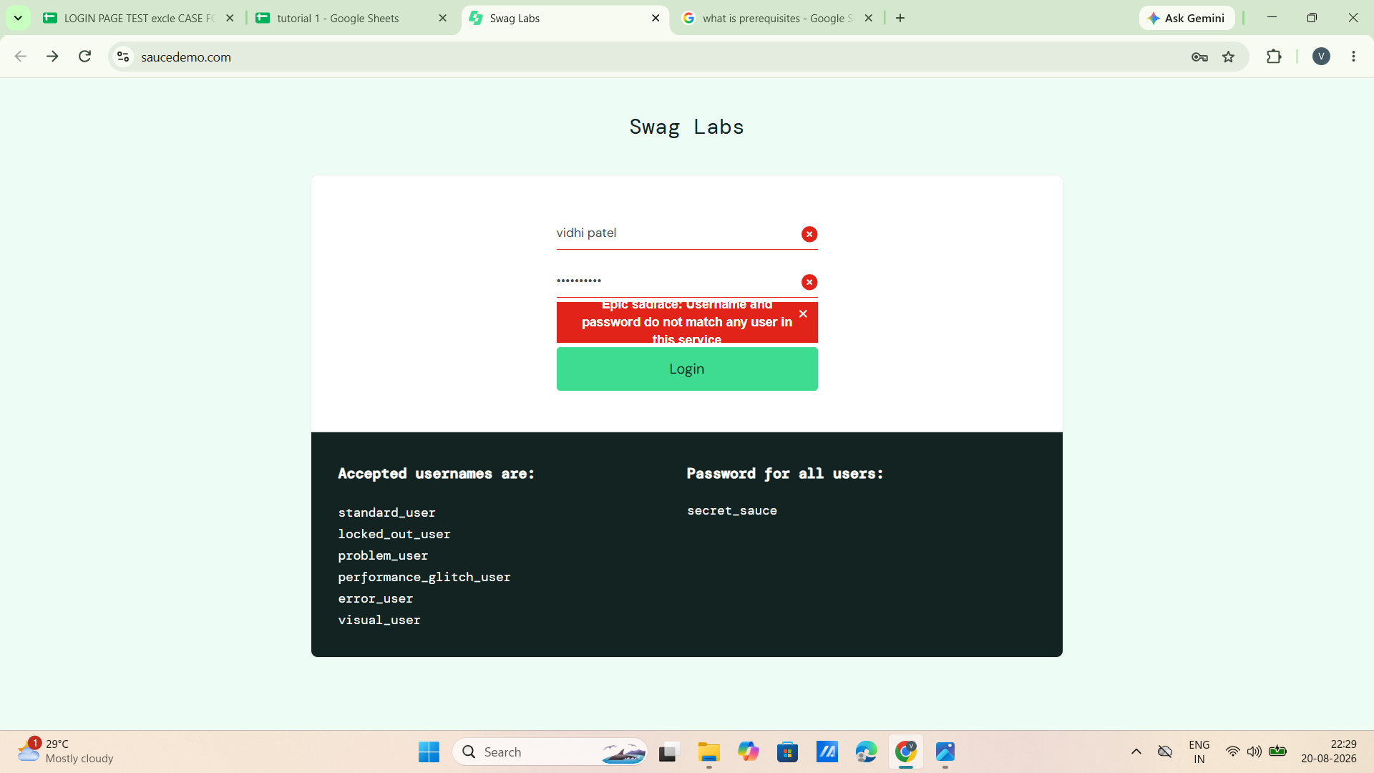

Scenario ID: 4
Scenario: Regression: login with invalid username and invalid password
Test steps:
- Enter invalid username : vidhi patel
- Enter invalid password : Godisgreat
- Click on login
Expected: Epic sadface: Username and password do not match any user in this service
Actual: Error displayed: Epic sadface: Username and password do not match any user in this service
Status: Pass

Scenario ID: 5
Scenario: Regression: login with empty username
Test steps:
- Leave blank at username : -
- Enter valid password : secret_sauce
- Click on login
Expected: Epic sadface: Username is required
Actual: Error displayed: Epic sadface: Username is required
Status: Pass

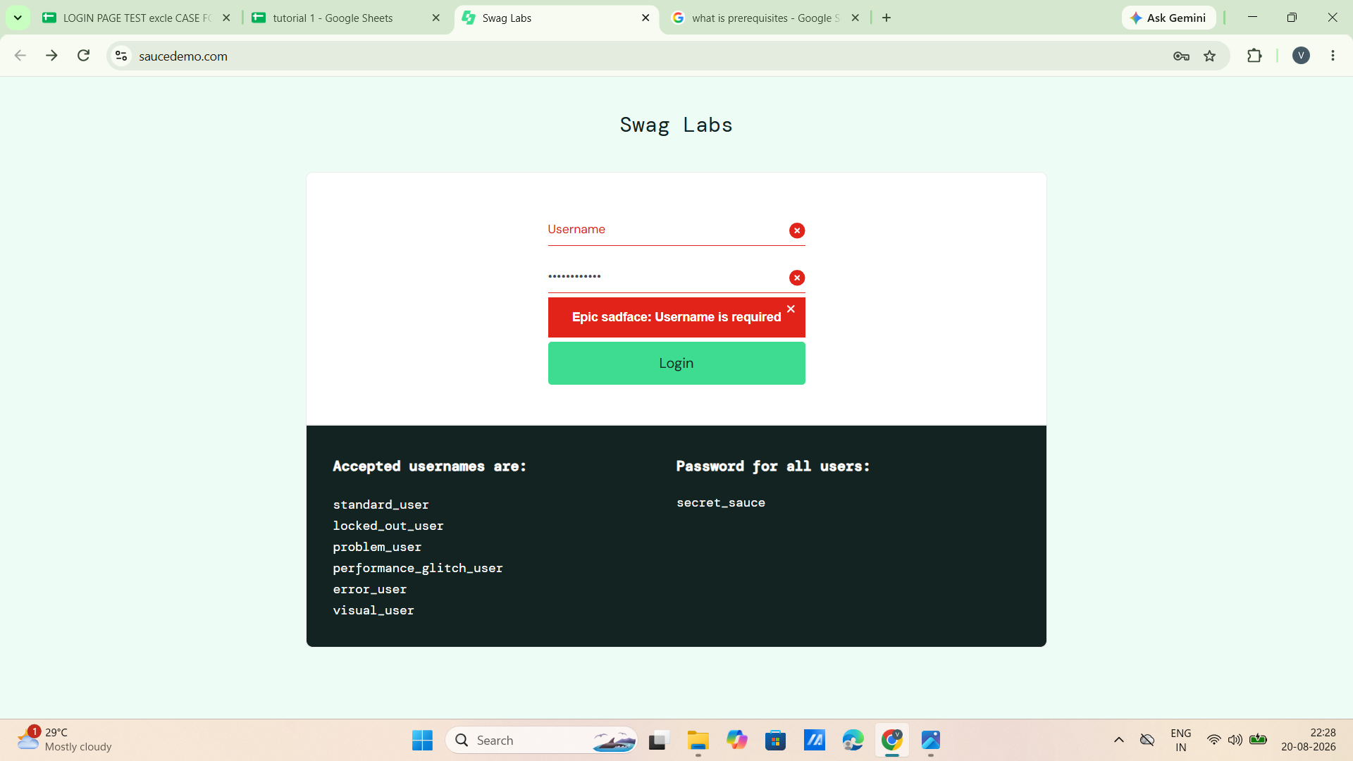

Scenario ID: 6
Scenario: Regression: login with empty password
Test steps:
- Enter valid username : standard_user
- Leave blank at password : -
- Click on login
Expected: Epic sadface: Password is required
Actual: Error displayed: Epic sadface: Password is required
Status: Pass

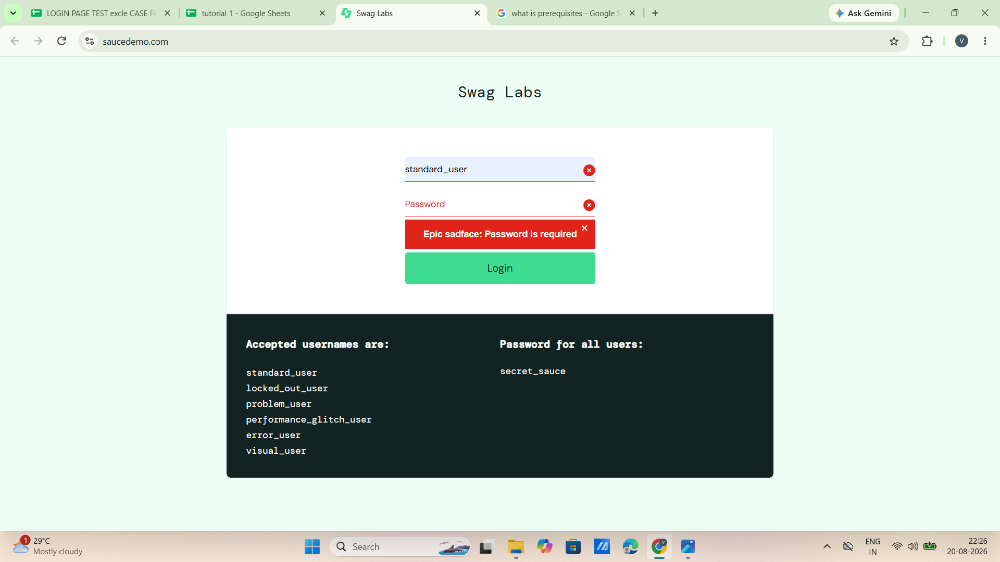

Scenario ID: 7
Scenario: Regression: login to Products page flow (integration)
Test steps:
- Login with standard_user / secret_sauce
- Check that the Products page opens with the product list
Expected: Products page opens with the product list
Actual: Products page opened with product list
Status: Pass

Scenario ID: 8
Scenario: Regression: add to cart and view cart
Test steps:
- Login with standard_user / secret_sauce
- Click on Add to cart for Sauce Labs Backpack
- Click on the cart icon and check the cart
Expected: Cart page shows Sauce Labs Backpack, qty 1, price $29.99
Actual: Cart page showed Sauce Labs Backpack, qty 1, price $29.99
Status: Pass

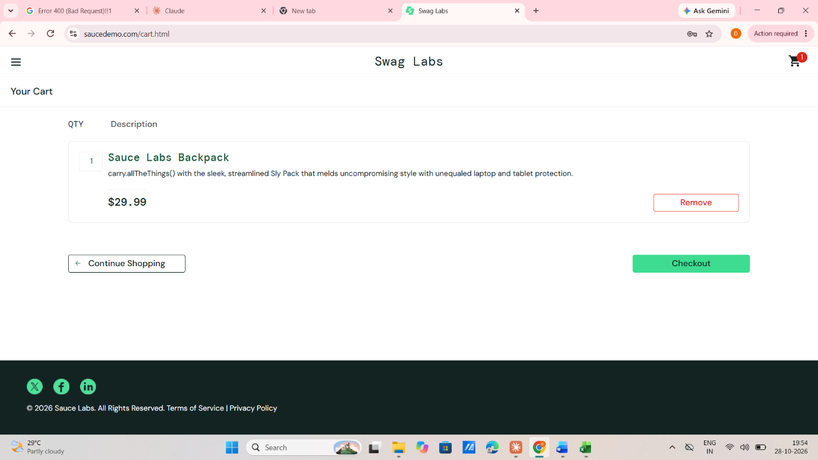

Module Analysis Table
Module | Functionality | Critical | Frequently Changed | Suitable for Automation | Reason
Login | User authentication | Yes | No | Yes | Frequently executed and stable
Products | Product list display | Yes | No | Yes | Same list verified on every build
Add to Cart | Add product to cart | Yes | No | Yes | Repeated operation
Cart | View items, qty, price | Yes | No | Yes | Repeated checks
Checkout | Customer details and order | Yes | Yes | No | Business logic changes frequently
Logout | Logout from application | No | No | Yes | Simple repetitive functionality
Automation Candidate Identification
Test Case ID | Functionality | Automation Recommended | Reason | Automation Tool
TC001 | Login (valid / invalid credentials) | Yes | Frequently executed | Selenium
TC002 | Login field validation | Yes | Stable, repetitive validation | Selenium
TC003 | Products page listing | Yes | Stable functionality | Selenium
TC004 | Add to Cart | Yes | Repetitive operation | Selenium
TC005 | View Cart | Yes | Repetitive operation | Selenium
TC006 | Checkout | No | Business logic changes frequently | Manual Testing
TC007 | Logout | Yes | Simple repetitive task | Selenium
Regression Test Suite
Reg. Test ID | Module | Scenario | Expected Result | Status
RT001 | Login | Valid login | Products page opens | Pass
RT002 | Login | Valid username, invalid password | Error message displayed | Pass
RT003 | Login | Invalid username, valid password | Error message displayed | Pass
RT004 | Login | Invalid username and password | Error message displayed | Pass
RT005 | Login | Empty username | Username is required | Pass
RT006 | Login | Empty password | Password is required | Pass
RT007 | Products | Login to Products page | Product list displayed | Pass
RT008 | Cart | Add to cart and view cart | Backpack, qty 1, $29.99 | Pass
Automation Feasibility Report
Criteria | Observation
Repetitive Test Cases | Yes
Stable Functionality | Yes
High Business Priority | Yes
Frequently Executed | Yes
Suitable Automation Tool | Selenium
Recommendation | Automate Login, Products, Add to Cart, Cart and Logout modules
Regression Testing Summary
Metric | Value
Total Modules Analyzed | 6
Automation Candidates | 5
Regression Test Cases | 8
Modules Excluded | 1 (Checkout)
Passed / Failed | 8 / 0 (100% pass)
Recommendation | Automate stable and repetitive modules; continue manual testing for frequently changing modules
Observation
Sr. No. | Observation | Remarks
1 | Login module suitable for automation | Yes
2 | Products, Add to Cart and Cart modules suitable for automation | Yes
3 | Checkout requires manual testing | Business logic changes frequently
4 | Regression test cases executed successfully | Pass
5 | Existing functionalities unaffected after update | Completed
Conclusion / Outcome
- Understood the concepts of Automation Testing and Regression Testing.
- Identified modules of Sauce Demo suitable for automation based on stability, frequency of execution and business importance.
- Prepared an Automation Feasibility Report and a Regression Test Suite.
- Executed regression test cases to ensure existing functionality remained unaffected.

